Project Proposal

**Version: 2.0**

**Last Update: 02/03/2019**

**Updated By: Daniel Beales**

**Team Molyneux 3**

Daniel Beales

James Masterton

Jordon Spowart

Contents

“Terrifying, lost in space feeling. Claustrophobic” 2

Outline 3

Description 3

Objective 3

Gameplay 3

Conditions 3

The winning condition 3

The losing condition 3

Target Platform 4

Operating System 4

Peripherals 4

Multiplayer 4

Development Tools 4

Game Engine 4

Design 4

Source Control 4

Management and Team Tools 5

Missions 5

Daniel Beales 5

James Masterton 5

Jordon Spowart 5

Team 5

Submission and Completion 5

# “Terrifying, lost in space feeling. Claustrophobic”

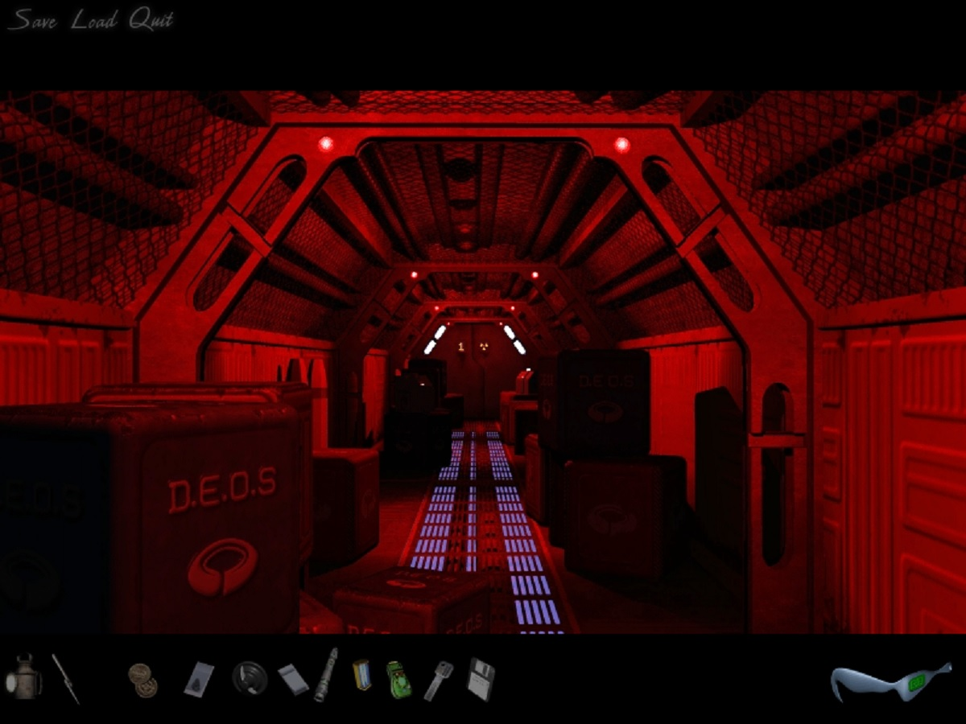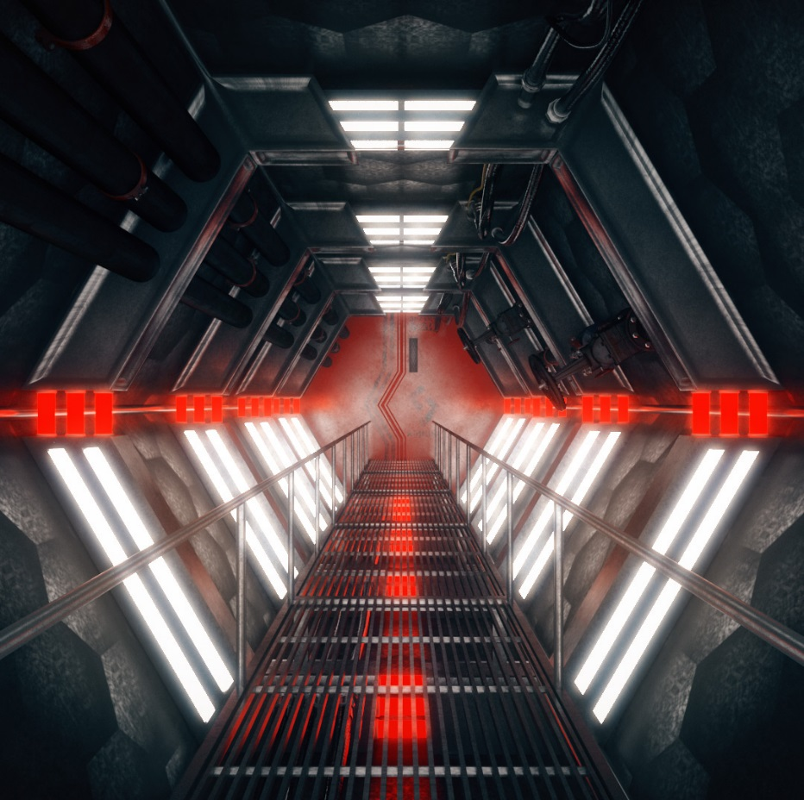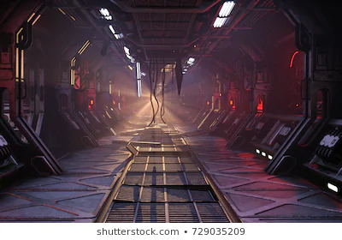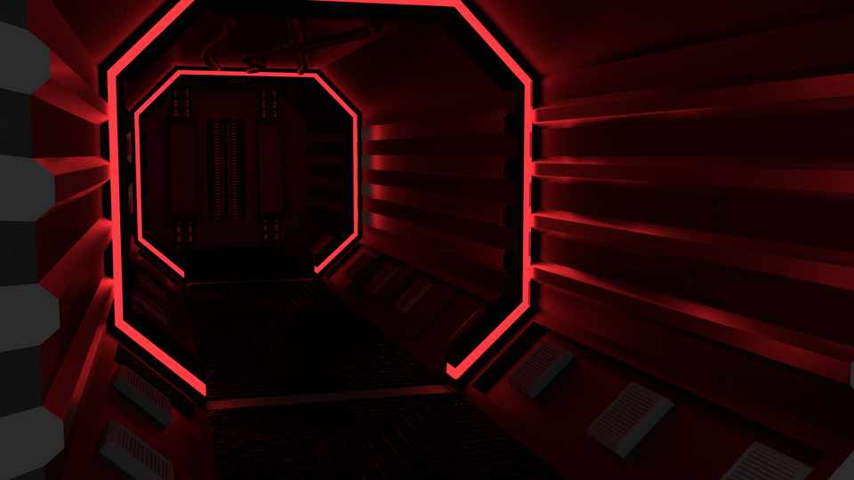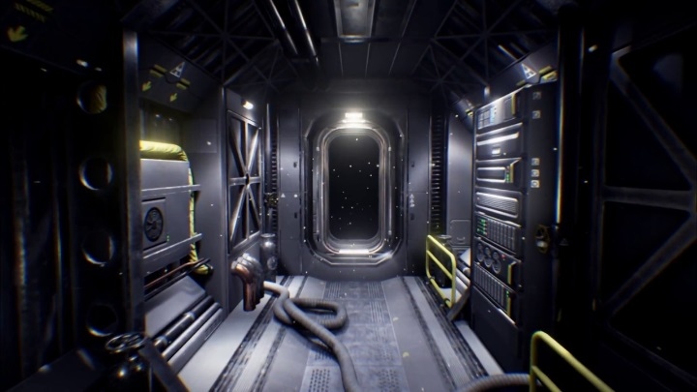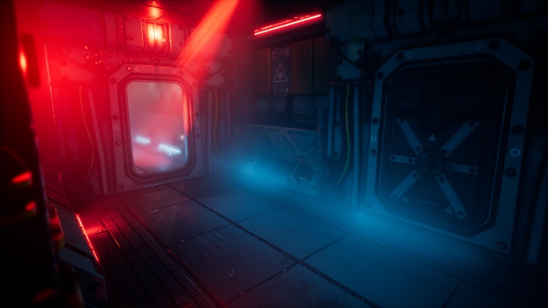

# Outline

### Description

Team Molyneux are aiming to create an immersive linear sci-fi work horror experience, that will receive emotional responses from the player using visual and sound cues. This game will revolve around being stuck within a crashed spacecraft with the intention to escape.

### Objective

The players sole objective in this experience is escape the crashed spaceship before the player suffocates. The suffocation is caused by the space craft being air sealed and the life support systems failing.

# Gameplay

The player will start within the spaceship, emergency lights and alarms will be blaring, and the area will be very poorly lit. The players sole task is to escape before they suffocate. There will be long corridors and locked doors. Some of the doors will unlock, others will not.

The player will be able to interact with control panels at the side of the doors. At the end of the maze the player will fall into a cave that the spaceship is hanging into.

# Conditions

The winning condition of this game is to survive and get to the end of the maze and make it to the cave.

To stop this winning condition becoming boring or monotonous the player will be made jump by sounds, and effects coming from doors that don’t open and the threat of suffocation consistently.

The losing condition of this game is purely suffocation. There will be a cut scene/animation simulating the effects of suffocation and the game will end.

The game is required to have a cheat function, to do this the player will either access and enable to cheat function in the menu or press the cheat interaction button and these will enable a torch. This will help the player see any extra visual clues on where they need to go to escape and will also take away a level of fear and suspense.

# Target Platform

### Operating System

The operating system this project will be designed for is Windows 7/8/10.

### Peripherals

The game will require a keyboard and mouse and will not have any extra/custom controller functionality at this time.

### Multiplayer

We will not be developing the game with the concept of multiplayer capabilities or a networked connection in mind.

# Development Tools

The development tools that will be used within this project will vary from team member, but on a primary basis every team member will be using the same game engine and version.

### Game Engine

Unreal Engine: 4.20.3

### Design

3D modelling programs will also be used, as a team we have access to Maya and a multitude of other development packages, but we may have to rely on free packages like Blender.

### Source Control

We will be using a source control program called GitHub to control the versions of our projects, while also keeping any documents and source files relevant to the production of the project on the repository that will be accessible to every team member.

***The repository can be found here:***

<https://github.com/dannybeales/Team-Molyneux-3>

# Management and Team Tools

The team will be managing weekly tasks set by the project manager using Trello. This will allow us as a team to see how each member is preforming on their tasks, Keeping tasks on time and managing workloads.

***Our project board can be found here:***

<https://trello.com/b/spFI2Jv9/team-molyneux>

The team will communicate using outlook and our Northumbria student emails and also meet in person every **Wednesday** at **13:15pm** at the university campus. This is allow us as a team to build our skills together, work on the project as a team and help other team members where needed. It is also much easier to communicate to other team members, especially when trying to explain design ideas using verbal communications rather than written.

# Missions

Daniel Beales – Project Management & Environment Creation

James Masterton – Gameplay Programming & 2D Art and Interface

Jordon Spowart – Interaction Programming & 3D Modelling

Team – Game Design & Testing

# Submission and Completion

Team Molyneux as a responsibility to get both documents and project files to the university for the set deadlines.

**Proposal and Skills Audit: 22nd February at 23:59pm 2019**

**Software and Documentation Presentation: 13th May 2019**